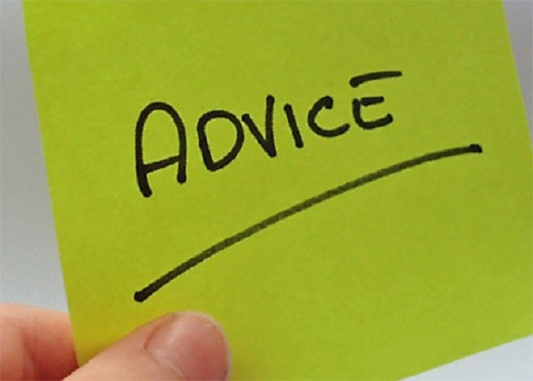
Stress: what is it and how can it be reduced?

Life in the 21st century is crazy! People spend hours in front on an idiot box, doing nothing and eating all sorts of crap they and their hand could reach for. They work day and night like donkeys, and still find no satisfaction in the work, and so they work more to find it. They laugh at clichés, and forget to appreciate the arts.
Enough said, let’s just get to the point! Life in the 21st century is crazy because people stress themselves out too much.
Now, think of life as a string, a violin string perhaps, and then, visualize the slight movement of the bow on that. If the pressure of the bow is just appropriate, the violin produces a melodious sound, but what if we go on increasing the pressure on the string? It reduces the chastity of the sound, and the sound becomes more and more corrupted. That’s what happens when you put in lots and lots of stress in your life; you lose the essence of life, and make it more and more corrupted.
A wise guy once said, ‘Life is not about getting anywhere, it is about enjoying every moment you have till you get anywhere.’ Now this ‘anywhere’ could be anywhere, maybe success, or happiness, or satisfaction, or the whole of them.
Scientists have recognized two kinds of stress that occur in our daily life-
1. Eustress (or the good stress) and
2. Stress (or simply the bad stress).
Eustress is what you would call the appropriate pressure on the bow, just the perfect tension on the string. It is something that motivates you to wake up, and live each day. The Bad stress, or simply stress, is something analogous to high pressure on bow, and high tension on the string. Stress corrupts your life, and makes you lose your general purpose in life.

Okay, now, it’s time for an exercise.
Stand up, and get yourself a pen and a paper. Once you have it, try answering the following question.
- What is life all about?
If you can find a ready answer to that, regress, and try harder, for there is just no answer to this question. Try finding harder and deeper into yourself and you will find a motivation, but not an answer.

Done with the exercise? Alright!
Here’s a bit of clarification on Eustress and Stress.
Eustress is when you work on a situation that is in your control, just like walking, and eating, anything that you do whose outcome is directly related to your action comes under Eustress.
Stress, on the other hand, is when you work on a situation that is not in your control, something similar to wading in mud, or learning to dance when you have already broken a leg!
A very common misconception that people have about stress is that it is related to time is some way or the other. Some people think that if they put in more hours into some activity, they’ll develop stress about it. Well, that’s partially true, but not completely true.
So, here’s what happens.
It doesn’t matter how many hours you put into anything, the only thing that matters is how you operate. So, if you are learning to dance, and if you are taught by the world’s expert on that, and that you really enjoy it, and that you have average expectation, then you’d surely become a dancing champion, even if you don’t have any legs at all!
But, on the contrary, if you are taught by some mediocre trainer, and that you doubt your ability to dance, and that you are not really enjoying it, then even if you have 15 legs, you won’t become a dancing champion, but you would become a highly stressed individual who has lost his purpose in life.
Summing up now, what should you do to reduce stress in life? Pretty simple, follow the following steps.
- Give up on things that are not in your control.
This single activity can save you a great part of your life. Many people wander around in life trying to make the impossible possible, but remember, no great thing was ever done without enthusiasm, and in our case, no great thing was ever done without Eustress.

- Have high dreams, but average expectations.
This step is to make your recovery from a fallen dream to dreaming a new dream easier and quicker. Don’t just submit to any plan, or method. Always have a backup plan, just in case the plan doesn’t work out.

- Have a proper self esteem.
This step requires you to have a proper self esteem, not so high that you appear cocky, and not so low that you find yourself in the gutters and working on the whims and fancies of others. Just try to strike a balance between the two scenarios.

So, here it is- the complete guide on what stress is and how to reduce it. I think you are feeling better already.

